INTRODUCTION
This project is based on an ShopEase system managed using the Jira tool. The main purpose of this project is to understand how real-world software development is planned, organized, and tracked using Agile methodology.
Instead of directly building a website, this project focuses on project management where different features of an online shopping system are divided into Epics, Tasks, and Sub-tasks. These include modules like User Management, Product Management, and Cart & Wishlist.
Jira is used to assign tasks, set priorities, track progress, and manage workflow in a structured manner. This helps in improving planning skills and understanding how teams work together in real software development environments.
The project provides hands-on experience of issue tracking, task management, and Agile workflow, making it useful for learning professional project management practices.

PROBLEM STATEMENT
In traditional project development, managing multiple tasks without a proper system becomes difficult. It is hard to track progress, assign responsibilities, and maintain clear communication between different parts of a project.
Without a structured tool, tasks may get delayed, mismanaged, or lack proper organization, especially when dealing with multiple modules like user management, product handling, and cart systems in an online shopping project.
There is a need for a system that can organize work in a clear structure, divide it into smaller manageable parts, and track progress effectively. This helps in avoiding confusion and improving overall workflow management.
To solve this issue, Jira is used as a project management tool to organize tasks into Epics, Tasks, and Sub-tasks, making the development process more systematic and efficient.

OBJECTIVES
The main objectives of this Jira-based ShopEase project are:
- To understand and implement project management using Jira tool.
- To organize work into Epics, Tasks, and Sub-tasks for better structure.
- To manage and track all project activities in a systematic way.
- To improve planning and collaboration skills using Agile methodology.
- To simulate a real-world software development workflow.
- To track progress of different modules like User Management, Product Management, and Cart System.
- To learn issue tracking, task assignment, and workflow management in Jira.

TOOLS & TECHNOLOGIES USED
The following tools and technologies were used in this Jira-based Online Shopping project:
- Jira Software: Used for project planning, issue tracking, and workflow management.
- Agile Methodology: Used to organize the project into Epics, Tasks, and Sub-tasks for better structure and continuous development.
- Kanban Board: Used to track progress through different stages such as To Do, In Progress, and Done.
- Web Browser: Used to access and manage the Jira project online.

METHODOLOGY
The project was developed using Jira tool by dividing the system into smaller modules for better organization. A structured approach was followed where the project was split into different Epics, Tasks, and Sub-tasks.
The workflow was managed using Jira boards where tasks moved through different stages like To Do, In Progress, and Done. This helped in tracking progress and maintaining proper organization of the project.
Issues such as tasks and bugs were created to represent different functionalities and testing scenarios.

PROJECT WORKFLOW
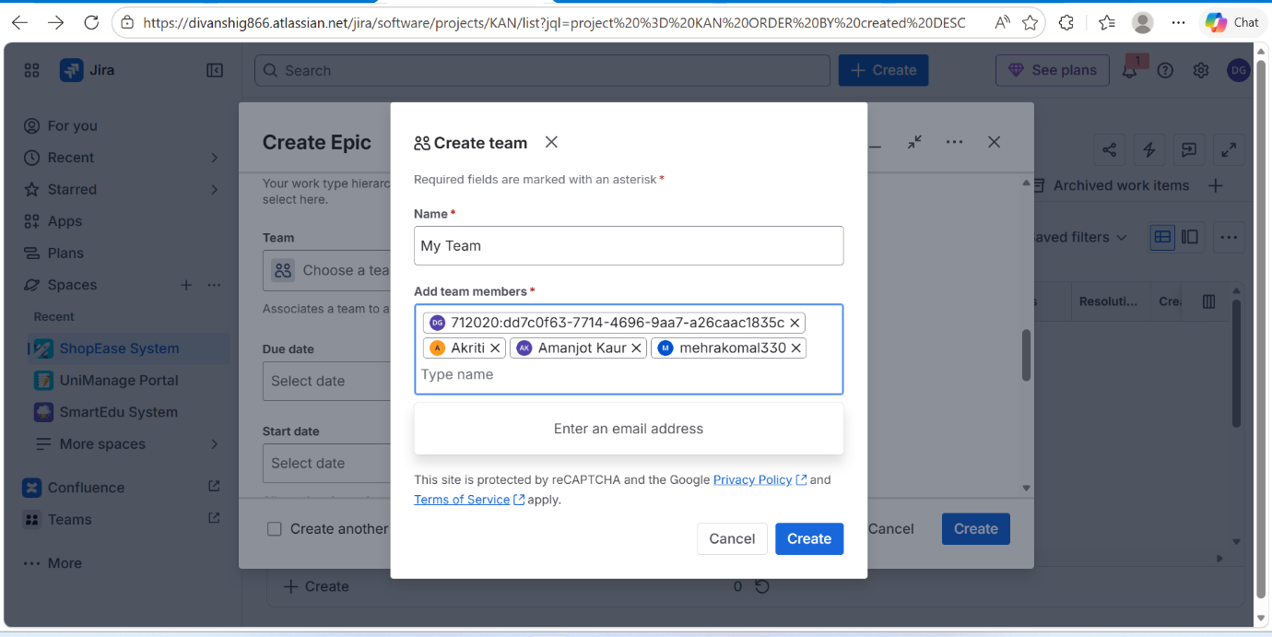
Creating and managing team members in Jira project
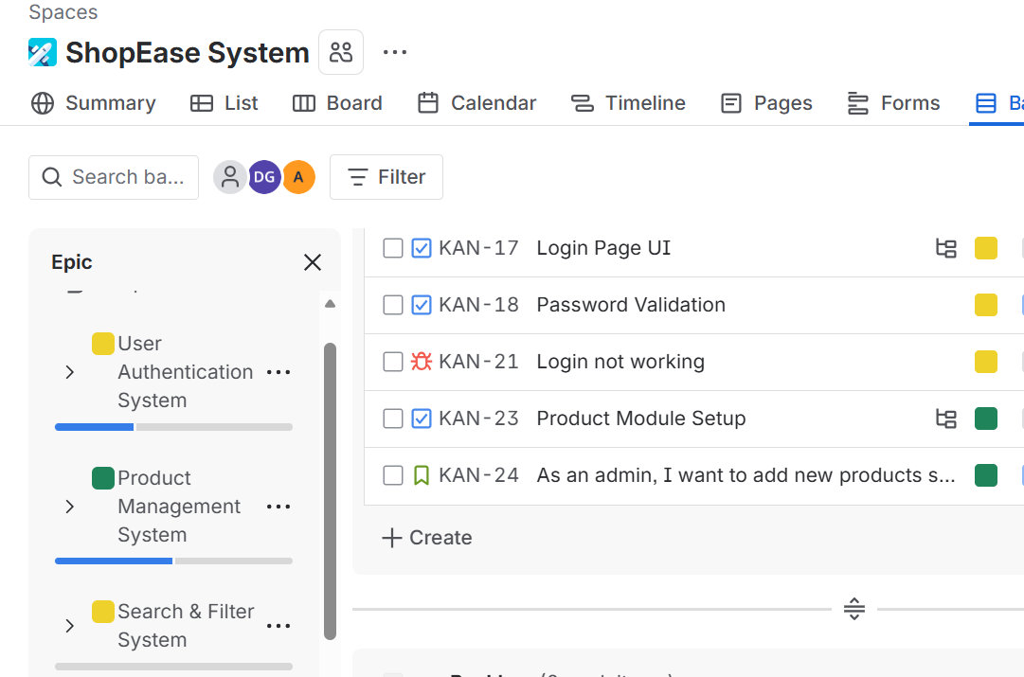
Epics: User Management, Product Management, and Search and Filter Syste

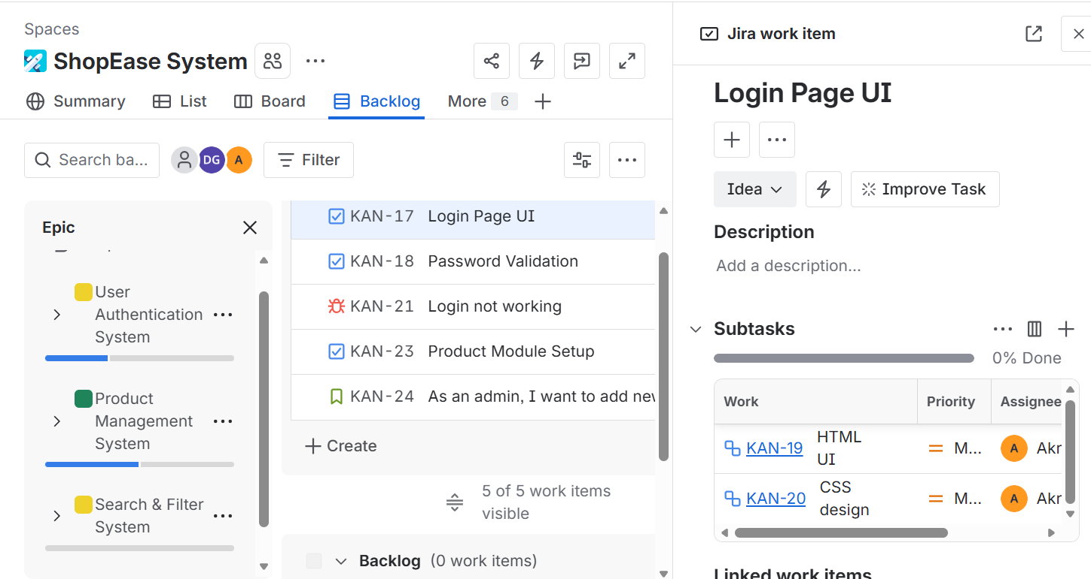

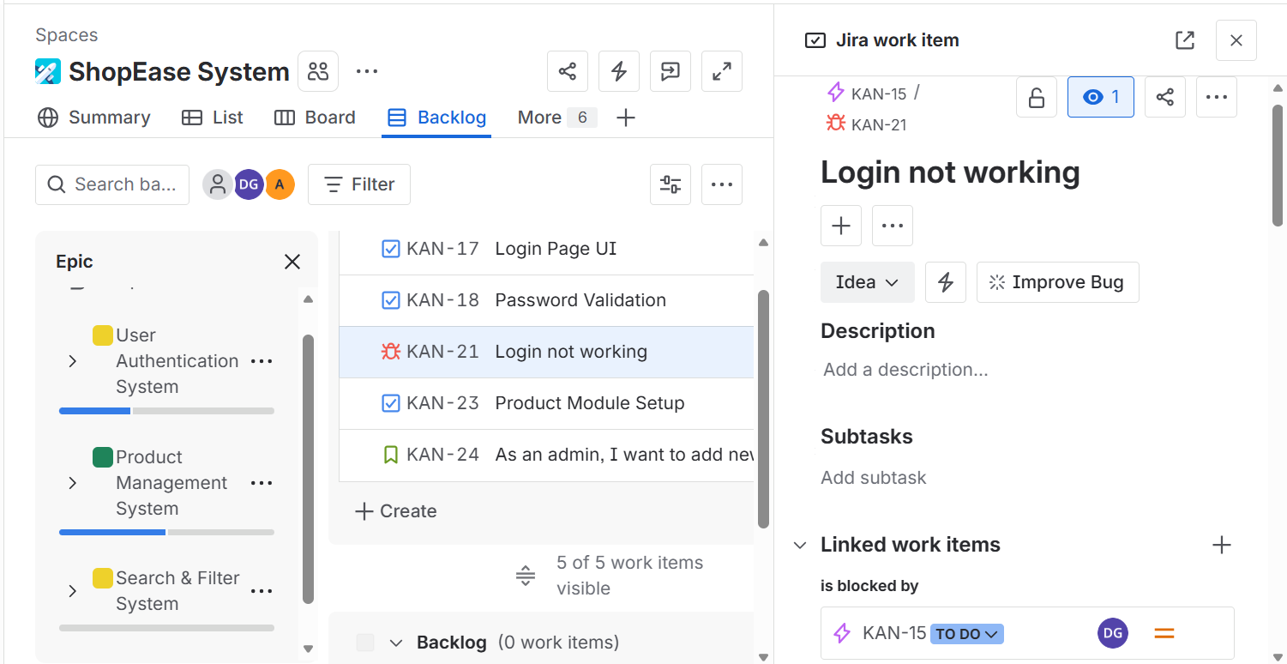
Create issues (tasks, Story, Sub tasks, Bugs)

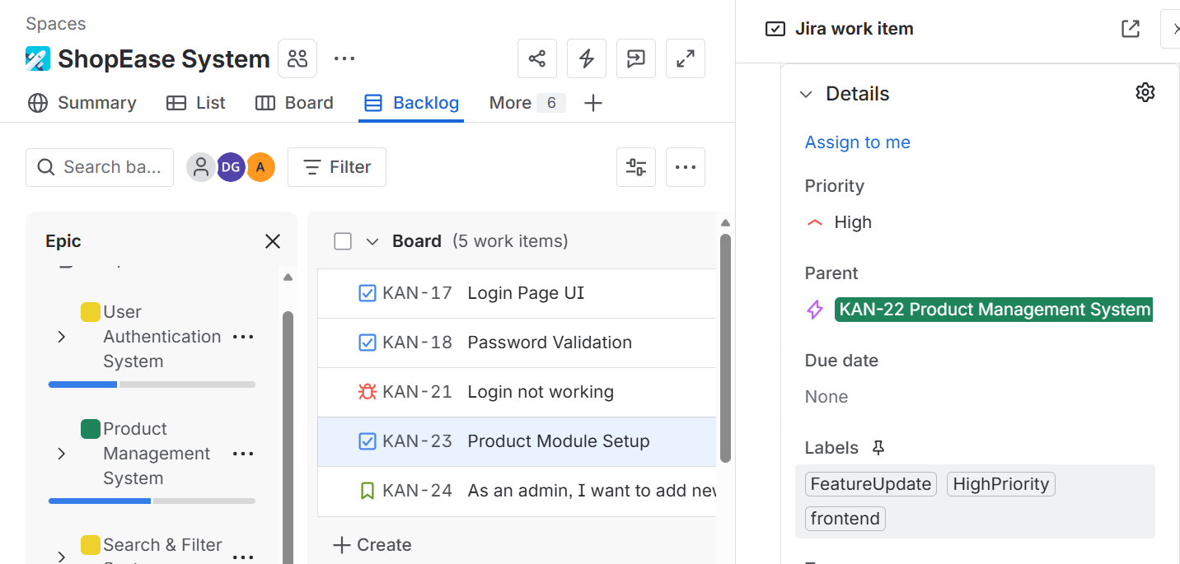
Task management in Jira using labels and assignees

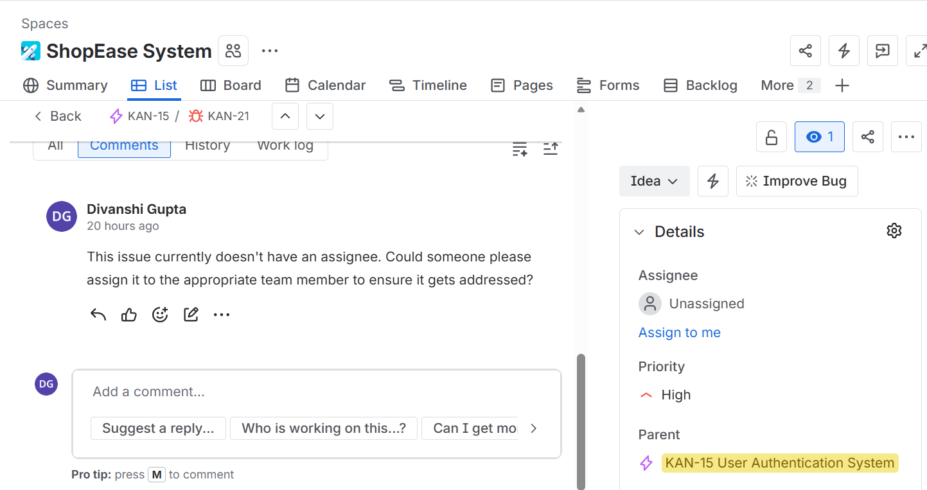
Jira comment section showing task updates

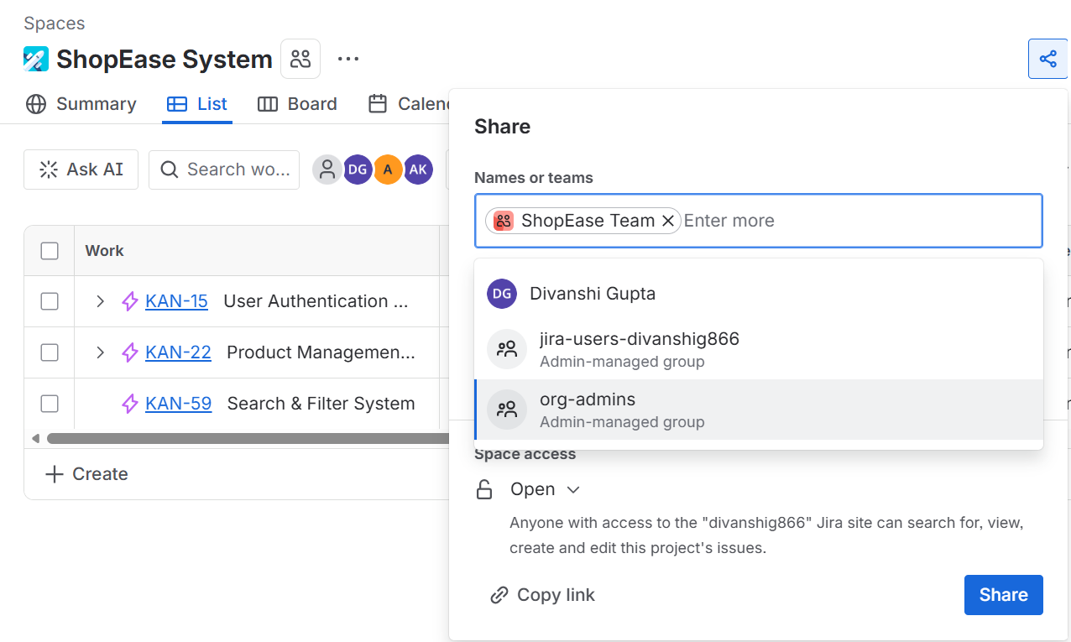
Shared Epic link for accessing project modules in Jira

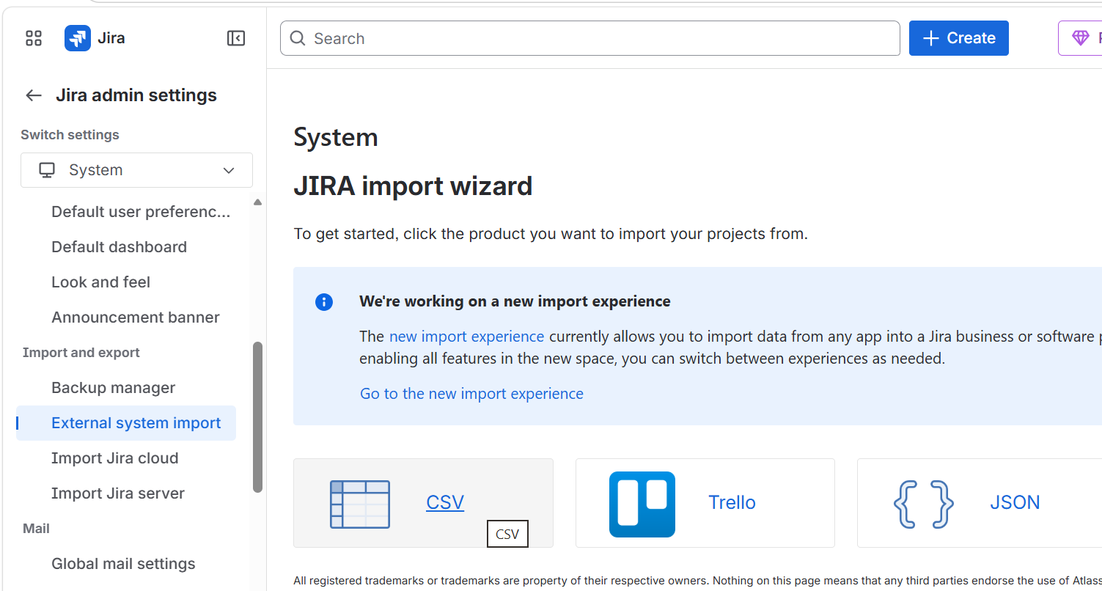

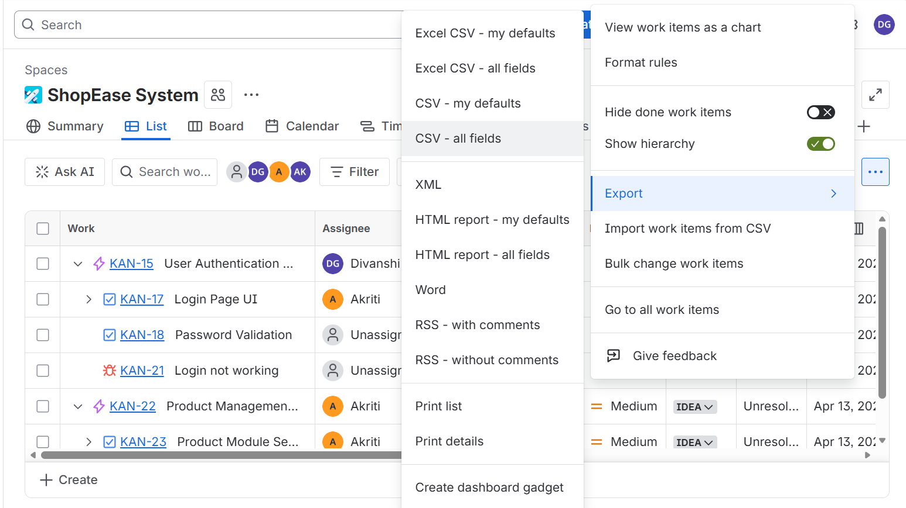

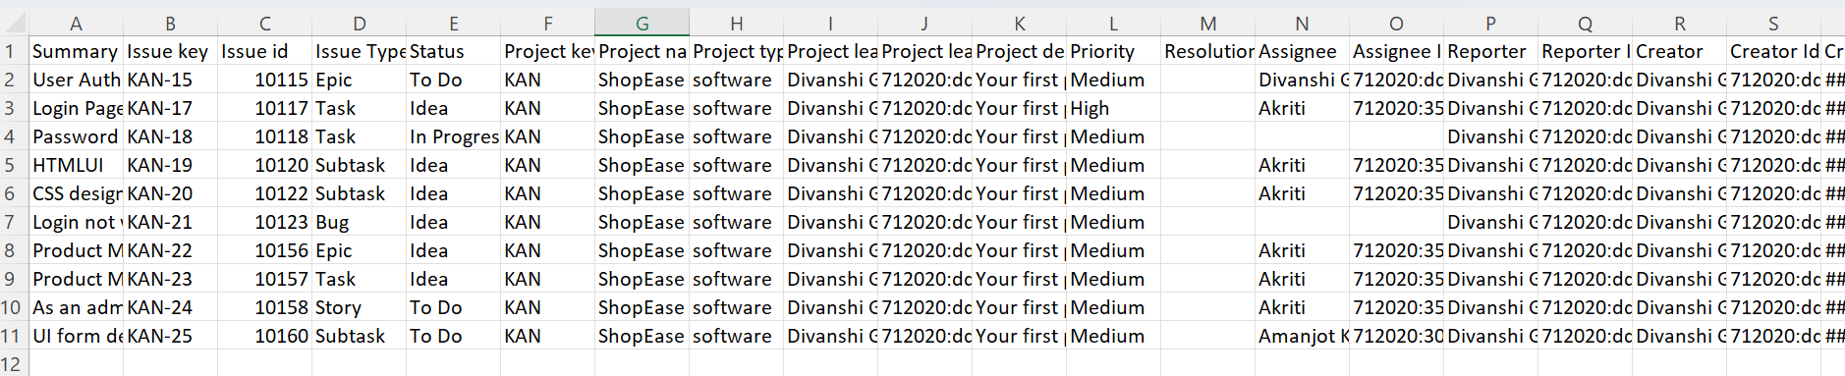Exporting and importing project data in Jira

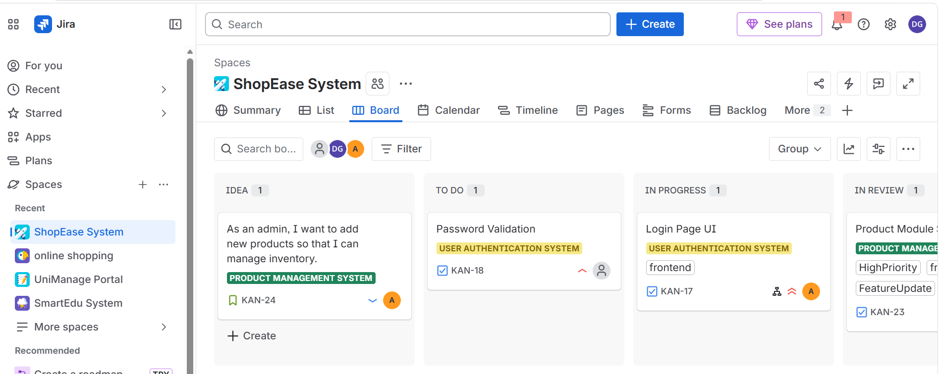
Jira board displaying workflow (To Do, In Progress, Done)

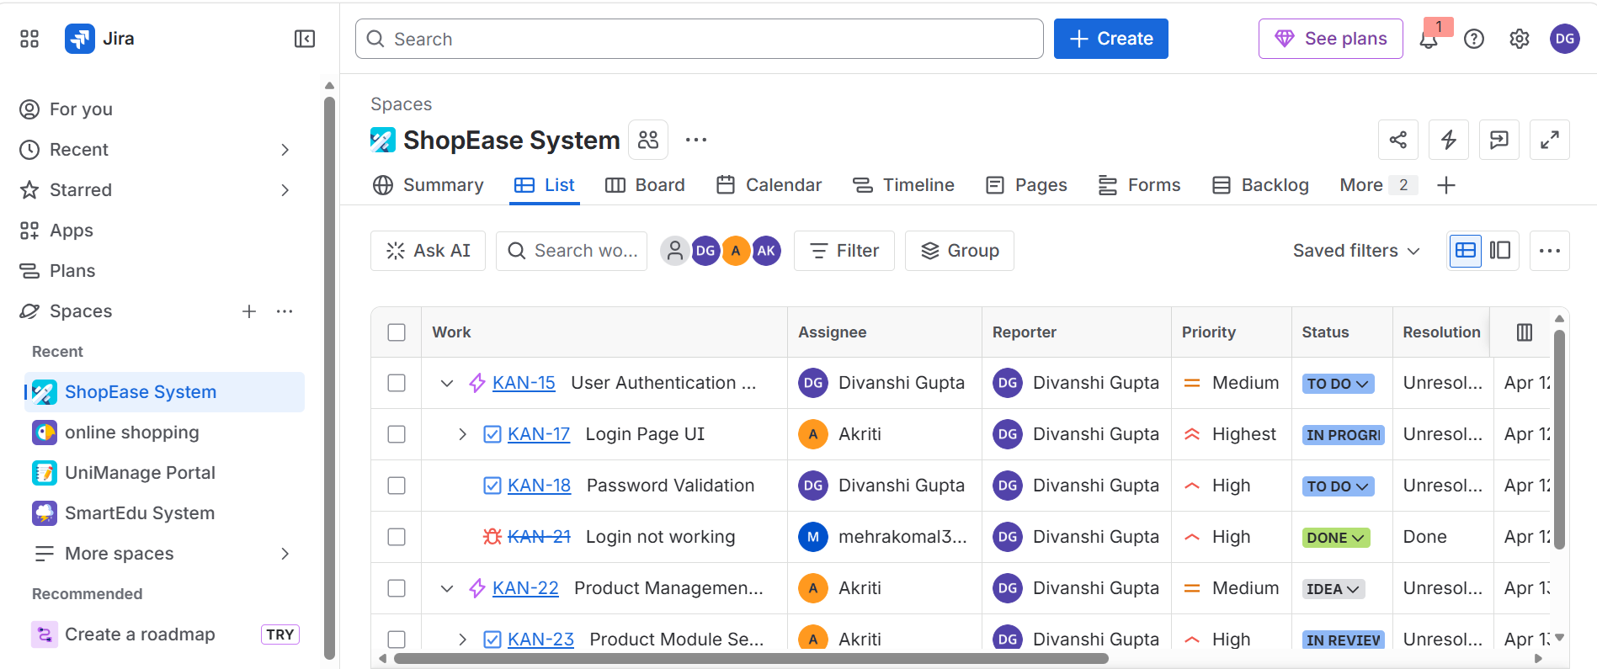
Jira dashboard showing overall project overview

IMPACT OF USING JIRA
Project Structuring Experience: Jira helped in organizing the entire Online Shopping project in a structured manner. The project was divided into Epics, Tasks, and Sub-tasks, which made it easier to understand each module and manage the work step by step.
Progress Visibility: It improved the visibility of work progress by showing the status of each task in different stages like To Do, In Progress, and Done. This made it easy to track what work is completed and what is pending.
Task Handling Improvement: It helped in handling multiple tasks in an organized way. Each task could be managed separately, which reduced confusion and improved overall efficiency.
Practical Workflow Understanding: It provided a clear understanding of how real project workflows work in software development. The movement of tasks from one stage to another showed the complete development cycle.
Learning and Development: This project helped in improving planning, organizing, and time management skills. It also gave practical exposure to project tracking and structured work management.

.IMPORTANCE OF USING JIRA
Efficient Project Management: Jira is an important tool because it provides a centralized platform to manage all project activities. It helps in keeping everything organized in one place.
Breaking Complex Work: It allows large and complex projects to be divided into smaller and manageable parts. This makes development more clear and easier to handle.
Effective Monitoring System: Jira provides a strong tracking system where the progress of every task can be monitored in real time. This helps in identifying delays or pending work easily.
Better Collaboration: It improves teamwork by allowing proper task assignment, updates, and communication within the project. This ensures smooth coordination between different activities.
Industry-Relevant Tool: Jira is widely used in software companies for project management. Learning it provides real-world industry experience and improves professional skills.

CONCLUSION
This project helped in understanding project management using Jira tool. The Online Shopping system was organized into Epics, Tasks, and Sub-tasks in a structured manner, which made the workflow clear and easy to manage. It also provided knowledge of task tracking through different stages like To Do, In Progress, and Done, improving planning and organizing skills.
Overall, this project helped in understanding how different project components are managed together in a single system. The use of Jira made the work more organized and transparent, and it gave a basic understanding of real-world software project management and tracking.

REFERENCES
Atlassian. (n.d.). Jira Software overview. https://www.atlassian.com/software/jira
Atlassian. (n.d.). Jira Software tutorials. https://www.atlassian.com/software/jira/guides
Atlassian. (n.d.). What is Agile?. https://www.atlassian.com/agile
Atlassian. (n.d.). Jira Software documentation. https://support.atlassian.com/jira-software-cloud/

GITHUB REPOSITORY LINK

